Information I’ve found about Albert Cave

He’s mentioned in the Book of Remembrance: St Thomas Church, Salisbury

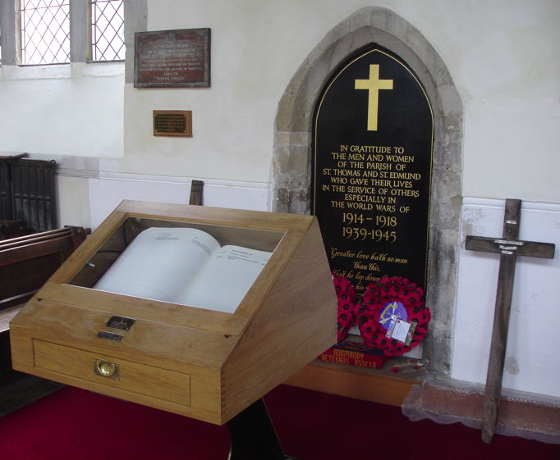

Rhostyllen War Memorial:
The Rhostyllen War Memorial commemorates those men of Rhostyllen and Bersham who died in conflicts throughout the world. The memorial, taking the form of two plaques, one in Welsh and one in English, mounted on stone, is sited in the Memorial Gardens.
Rhostyllen is a former mining village in the community of Esclusham, in the county borough of Wrexham. Until 1974, Rhostyllen was in the historic county of Denbighshire and, from 1974 to 1996, in the county of Clwyd.

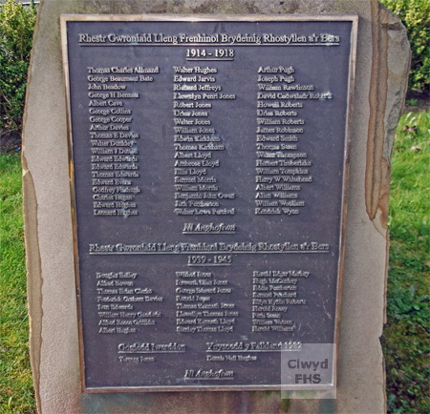

Name | Service | Died | Age | Details | Cemetery/Memorial
Gunner  Albert  CAVE  159288 | Royal Garrison Artillery (129th Heavy Bty.) | 28 Oct 1917 | 35 | Son of Thomas Cave, of Rhostyllen; husband of Minnie Gertrude Cave, of 1, Southside, St. Andrew's Road, Bemerton, Salisbury, England. | Dozinghem Militry Cemetery, West-Vlaanderen, Belgium.

DOZINGHEM MILITARY CEMETERY,

Cemetery is located at point ‘A’

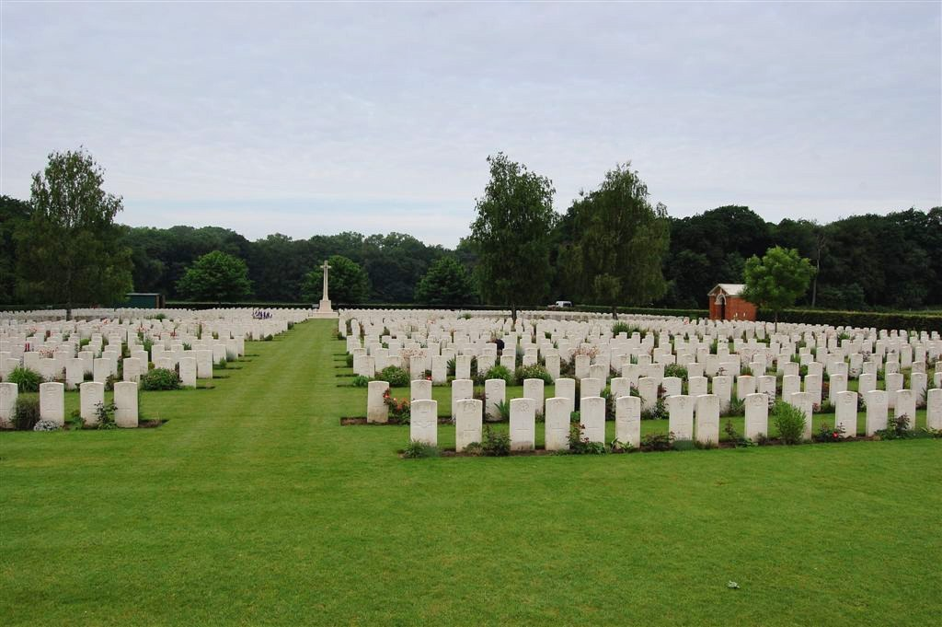

Cemetery Plan – Grave stone located in the middle of the row within the red box below.
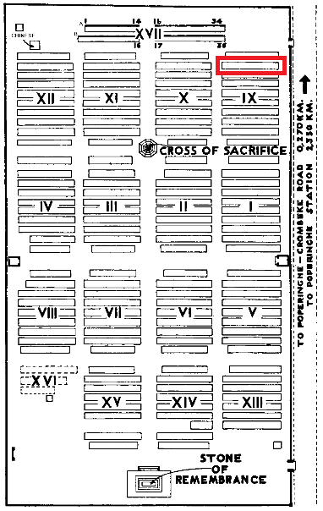

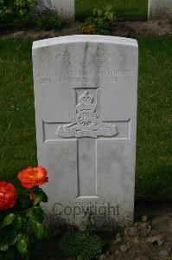

The Heavy Batteries of the Royal Garrison Artillery
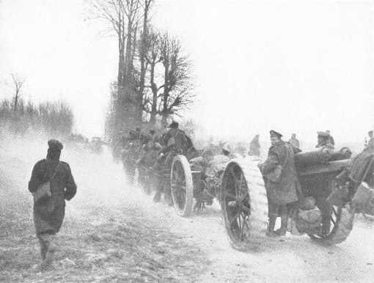
A Heavy Battery of the RGA tows its 60-pounder guns along the roads of Northern France.
The role of the Heavy Battery
Heavy Batteries RGA were equipped with heavy guns, sending large calibre high explosive shells in fairly flat trajectory fire.The usual armaments were 60 pounder (5 ich) guns, although some had obsolescent 5 inch howitzers. As British artillery tactics developed, the Heavy Batteries were most often employed in destroying or neutralising the enemy artillery, as well as putting destructive fire down on strongpoints, dumps, store, roads and railways behind enemy lines. The armaments of each battery will be given as details are added.
129th | Deployed: France, 27 March 1916

Died from his wounds on 28th October 1917 in I believe The third battle of Ypres (or Passchandaele)
